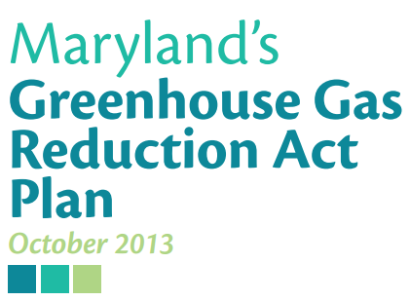
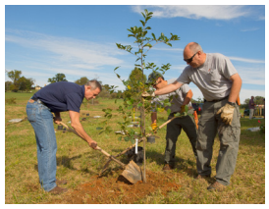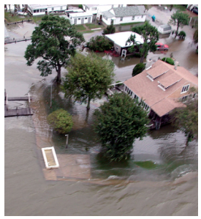

What are the impacts of climate change on Maryland?
Watch the video found here: http://climatechange.maryland.gov/news-and-events/mayor-of-chestertown-discusses-impact-of-climate-change/
List the ways climate change is impacting Chestertown.

List a few ways that Chestertown is fighting back against climate change.

Why do you think fighting against climate change is so important in places like Chestertown?

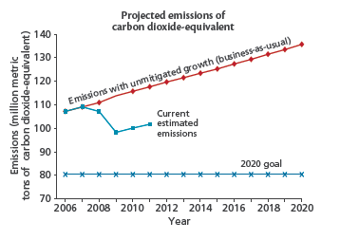

What is the current estimated emissions?

What is the goal for emissions in 2020?

According to this graph, why is it so important to address emission reduction right now? Cite specific evidence from the text to support your answer.

Maryland is vulnerable
Maryland is among the states most vulnerable to climate change. Rising sea levels, along with increased storm intensity, will have devastating and far-reaching environmental and economic impacts on the Chesapeake Bay and on the quality of life Marylanders enjoy. Maryland’s sizable farming community could suffer costly losses during extreme droughts and heat waves. Marylanders everywhere will face increased risk of flooding and significant property damage as a result of heavier precipitation and other extreme weather events. Children, the elderly, and other sensitive populations are vulnerable to the effects of heat waves and increased air pollution. For these reasons, addressing climate change must be among the State’s highest priorities.
Why is Maryland especially susceptible to climate change?

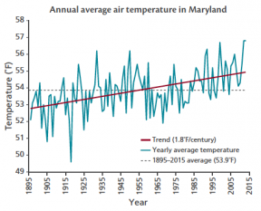
Data from the National Climatic Data Center illustrates that temperatures in Maryland have increased ~1.8ºF per century since 1895.
Maryland temperatures are rising
The Intergovernmental Panel on Climate Change concluded that we cannot deny that the earth is warming, and that most of the observed increases in temperatures are related to increases in greenhouse gas emissions over the last 50 years. Long-term temperature data show that average temperatures in Maryland have risen in the last century and will continue to rise in the future. Marylanders around the State are already noticing warmer winter days, more intense heat and humidity in the summer, and more damage due to storms.
Based on the information in the graph, why might some say that recorded temperature changes are no big deal?

According to this section, what are the outcomes of rising temperatures?

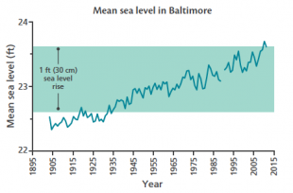
The long-term tide gauge in Baltimore Harbor shows a steady rise in sea level since the early 1900s.
Coastal sea levels are rising in Maryland
Historic tide gauge records demonstrate that sea levels are rising along Maryland’s coast. Due to a combination of global sea level rise and land subsidence, sea levels have risen approximately one foot within Maryland’s waters over the last 100 years. As our climate changes, sea levels are expected to continue to rise— potentially twice as fast as during the 20th century. Maryland is at risk of experiencing another one-foot rise in sea level by 2050 and as much as a three-foot rise by 2100, contributing to higher storm wave heights, greater flooding in low-lying coastal areas, exacerbated shoreline erosion, and damage to property and infrastructure. The sea level rise map depicts the counties in Maryland that are the most vulnerable to sea level rise.
What is the impact of the rise in sea level?

What is different about expected sea level rises and sea level rises over the last one hundred years?

Based on the chart how much did the sea level rise between 1985 and 2014?

Extreme events are more frequent
Maryland is experiencing more frequent extreme rain and storm events, and more flooding as a result of sea level rise and coastal storms. August and September of 2011 were the State’s wettest in 117 years. Increasing temperatures, which allow air to trap more moisture, will make these storm events more common. July of 2011 and 2012 were the second and third hottest on record. Extreme events affect human health both directly and indirectly. Warmer temperatures and poor air quality increase respiratory illness and other health problems in our vulnerable populations. Extreme events can directly damage infrastructure such as water treatment and supply, transportation, and electricity systems.
Why are we having more extreme weather?

Think of a time when you have recently experienced an extreme weather event. Describe the event. What happened? What did you see, hear? How did you feel?

What is Maryland’s plan to address climate change?
Summary of the Plan
To achieve a 25 percent reduction in Maryland’s greenhouse gas emissions by 2020, the State, through its implementation of the 150-plus programs and initiatives described in the Plan, must reduce Maryland’s greenhouse gas emissions by 55 million metric tons of carbon dioxide-equivalent annually. This reduction includes offsetting growth that is expected to occur between 2006 and 2020 (called the ‘business-as-usual’ forecast).
Comprehensive plan
The Plan is a comprehensive, multi-sector, multi-agency plan that incorporates many innovative strategies. This includes programs that do not directly reduce carbon dioxide-equivalent, but rather absorb carbon dioxide from the atmosphere. The State has held numerous public and stakeholder meetings and has been receptive to a broad range of ideas. More than a dozen state agencies and non-governmental organizations assisted in drafting the Plan.
What is the main goal of Maryland’s plan to address climate change?

Based on what you have learned about climate change so far, what do you think the plan means when it talks about, “programs…[that] absorb carbon dioxide from the atmosphere?” What does that?

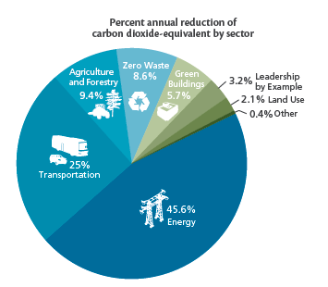
What are the two largest categories that will be responsible for decreasing greenhouse emissions in Maryland? What percentage of the plan are they?

Out of all of these areas, what area do you think you could have the greatest impact? Explain your answer.

Key Programs in Maryland’s Climate Change Plan
Below is a chart that lists ten key programs in Maryland’s climate change plan. Each program has a description. For each program summarize what the plan is asking them to do and complete the chart.
Program | Description | Summary
Maryland Renewable Energy Portfolio Standard | The intent of this law is to establish a market for new sources of mostly in-state renewable electricity generation by requiring that Maryland power providers supply 18 percent of electricity from renewable sources by 2020, increasing to 20 percent  renewables by 2022. If ‘black liquor’ and other carbon-emitting fuels are eliminated as qualiﬁ ed sources, and if the State’s Portfolio Standard is accelerated to require 25 percent of energy consumed by 2020, additional reductions would be realized.
EmPOWER Maryland | Enacted in 2008, the EmPOWER Maryland Energy Efficiency Act set a target to reduce both Maryland’s per capita total electricity consumption and peak load demand by 15 percent by 2015. EmPOWER includes numerous State- and utility-managed energy efficiency and conservation programs. The optimization of these programs should allow the State to increase its per capita electricity consumption reduction target above 15 percent and enable Maryland to achieve additional reductions.
Zero Waste | Zero waste is a concept that calls for the near-elimination of solid waste sent to landﬁlls or incinerators for disposal. Instead, the vast majority of Maryland’s solid waste will be reused, recycled, composted, or prevented through source reduction.
Maryland Clean Cars | The Maryland Clean Cars Program adopts California’s stricter vehicle emission standards and directly regulates carbon dioxide emissions. These standards became effective in Maryland for model year 2011 vehicles, signiﬁcantly reducing a number of emissions including volatile organic compounds and nitrogen oxides.
Regional Greenhouse Gas Initiative | The Maryland Clean Cars Program adopts California’s stricter vehicle emission standards and directly regulates carbon dioxide emissions. These standards became  effective in Maryland for model year 2011 vehicles, signiﬁcantly reducing a number of emissions including volatile organic compounds and nitrogen oxides.
Building Codes | Given the long life of most buildings, upgrading State and local building codes to include minimum energy efficiency requirements provides long-term emissions savings. Maryland’s Building Performance Standards are updated by regulation every three years following the three-year cycle of the International Code Council.
Public Transportation Initiatives | For several decades, vehicle miles traveled have risen faster than the increase in population in Maryland and nationwide, and land use development over the past 40 to 50 years has put more people living beyond the reach of easy access to transit facilities. Planned transit and Transit Oriented Development expansions in  Maryland should lessen vehicle miles traveled in the State.
Corporate Average Fuel Economy  (CAFÉ)  Standards | First enacted by Congress in 1975, the purpose of the CAFE standard is to reduce energy consumption by increasing the fuel economy of cars and light trucks. Since introduction in 1975, CAFE standards have increased from the initial 18 miles per gallon standard to 35 miles per gallon by 2020, as established in the Federal Energy  Independence and Security Act of 2007.
Managing Forests to Capture Carbon | Managing forests to capture carbon will promote sustainable management  practices in existing Maryland forests on public and private lands. Th e enhanced productivity resulting from enrolling unmanaged forests into management regimes will increase the amount of carbon captured in forest biomass, amounts of carbon  stored in harvested, durable wood products, and availability of renewable biomass for energy production.
Planting Forests in Maryland | Planting trees expands forest cover and associated carbon stocks by regenerating or establishing healthy, functional forests through practices such as soil preparation, erosion control, and supplemental planting to ensure optimum conditions to support forest growth. The implementation goal is to achieve the afforestation and/or reforestation of 43,030 acres in Maryland by 2020.

Now take each program and put them into the category of the pie graph you looked at previously. For each category record the percentage of each sectors responsibility for reducing greenhouse gases.
Sector | Programs | % of Responsibility
Green Building
Zero Waste
Agriculture and Forestry
Transportation
Energy

What Can You Do?
Read the following list of things the Maryland Climate Change Plan suggests that you can do. Think about each one and decide if it is actually something you, a 6th grade middle school student can do. If you think you can do it, write a brief sentence that describes how you could implement the suggestion in your daily life. An example is provided.
Use energy-saver light bulbs, such as compact fluorescents.
Yes or No: _____Yes____________________________________________________
Explanation: __I can ask my mom to buy these kinds of light bulbs and tell her why it is important_________________________________________________________
Purchase Energy Star appliances, electronics, and lighting.
Yes or No: ____________________________________________________________
Explanation: ___________________________________________________________
____________________________________________________________________
Unplug all electronics when not in use, for example: your cell phone charger, TV, toaster, coffeemaker, computer.
Yes or No: ____________________________________________________________
Explanation: ___________________________________________________________
____________________________________________________________________
Install ceiling fans, window fans, and whole-house fans as a low-energy way to cool the house in summer.
Yes or No: ____________________________________________________________
Explanation: ___________________________________________________________
____________________________________________________________________
Upgrade your heating and cooling system with an energy efficient one, including a programmable thermostat.
Yes or No: ____________________________________________________________
Explanation: ___________________________________________________________
____________________________________________________________________
Clean the lint filter on your dryer for higher efficiency, or hang your clothes outside on a line to dry (or inside on a rack).
Yes or No: ____________________________________________________________
Explanation: ___________________________________________________________
____________________________________________________________________
Sign up for renewable energy through your electric company.
Yes or No: ____________________________________________________________
Explanation: ___________________________________________________________
____________________________________________________________________
Weatherproof your home, sealing cracks and gaps.
Yes or No: ____________________________________________________________
Explanation: ___________________________________________________________
____________________________________________________________________
Buy furniture made from sustainable materials, such as bamboo and reclaimed wood.
Yes or No: ____________________________________________________________
Explanation: ___________________________________________________________
____________________________________________________________________
Use a reel lawnmower, which is quiet and has zero emissions.
Yes or No: ____________________________________________________________
Explanation: ___________________________________________________________
____________________________________________________________________
Always maintain your septic system, including gas emissions.
Yes or No: ____________________________________________________________
Explanation: ___________________________________________________________
____________________________________________________________________
Opt out of paper catalogs, phone books, and other ‘junk’ mail.
Yes or No: ____________________________________________________________
Explanation: ___________________________________________________________
____________________________________________________________________
Bring reusable canvas totes to use at the grocery store.
Yes or No: ____________________________________________________________
Explanation: ___________________________________________________________
____________________________________________________________________
Buy your produce locally to decrease the amount of vehicle miles that your food has to travel.
Yes or No: ____________________________________________________________
Explanation: ___________________________________________________________
____________________________________________________________________
And, remember, always reduce, reuse, and recycle!
Yes or No: ____________________________________________________________
Explanation: ___________________________________________________________
____________________________________________________________________
Cycle instead of driving.
Yes or No: ____________________________________________________________
Explanation: ___________________________________________________________
____________________________________________________________________
Walk short distances rather than drive.
Yes or No: ____________________________________________________________
Explanation: ___________________________________________________________
____________________________________________________________________
Use public transportation or carpool for long trips.
Yes or No: ____________________________________________________________
Explanation: ___________________________________________________________
____________________________________________________________________
Take advantage of telecommuting.
Yes or No: ____________________________________________________________
Explanation: ___________________________________________________________
____________________________________________________________________
Shop online instead of using your car to drive to stores.
Yes or No: ____________________________________________________________
Explanation: ___________________________________________________________
____________________________________________________________________
Combine trips to the grocery store, library, and other places into one.
Yes or No: ____________________________________________________________
Explanation: ___________________________________________________________
____________________________________________________________________
Consider buying a fuel-efficient, low-greenhouse gas-emitting vehicle, such as a hybrid, electric, or diesel.
Yes or No: ____________________________________________________________
Explanation: ___________________________________________________________
____________________________________________________________________
Maintain your vehicle by getting a tune-up, an oil change, and properly inflating your tires.
Yes or No: ____________________________________________________________
Explanation: ___________________________________________________________
____________________________________________________________________
Drive efficiently: maintain the speed limit, use cruise control, decrease the weight of the car, and avoid idling.
Yes or No: ____________________________________________________________
Explanation: ___________________________________________________________
____________________________________________________________________
Reduce air friction by only using roof racks when necessary.
Yes or No: ____________________________________________________________
Explanation: ___________________________________________________________
____________________________________________________________________
Buy a home in a Low Impact Development area, if possible.
Yes or No: ____________________________________________________________
Explanation: ___________________________________________________________
____________________________________________________________________
Buy a home near your work to reduce commuter miles.
Yes or No: ____________________________________________________________
Explanation: ___________________________________________________________
____________________________________________________________________
Landscape with native trees and plants, and install rain gardens to reduce the amount of impervious surface on your property.
Yes or No: ____________________________________________________________
Explanation: ___________________________________________________________
____________________________________________________________________

